[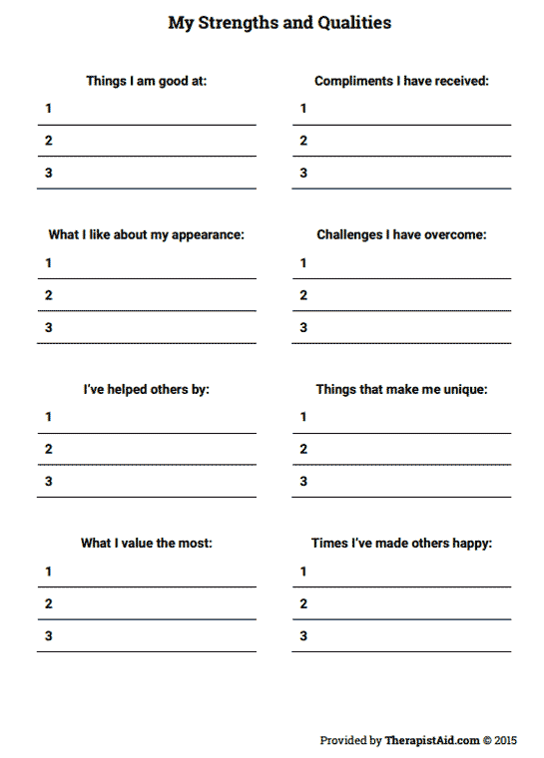](https://www.google.com/url?sa=i&rct=j&q=&esrc=s&source=images&cd=&cad=rja&uact=8&ved=0ahUKEwjA5bSwsI_PAhUI6WMKHfGlCw0QjRwIBw&url=http%3A%2F%2Fwww.therapistaid.com%2Ftherapy-worksheet%2Fmy-strengths-and-qualities&psig=AFQjCNFKghEn2X9V-aTx14mgrchBfxgE_w&ust=1473960235842244)